Assignment 15.1

Create an employee table with following properties (id, Name, Department, Salary, Location) in Mysql.

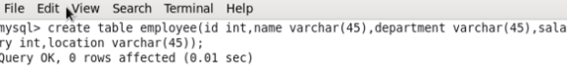

Add 10 rows in the above employee table.

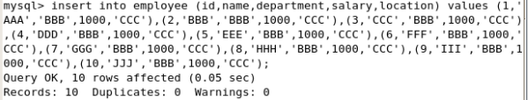

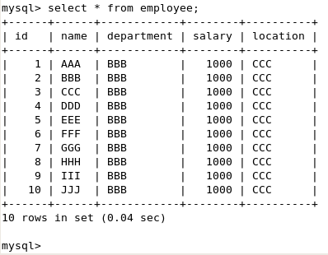

Import the above table it into the HDFS directory using Sqoop.

sqoop_import_to_hdfs.PNG

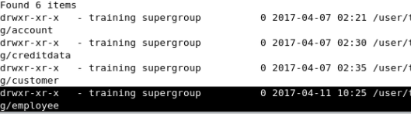

Import the above table it into a new Hive table EMP\_DATA using Sqoop.

sqoop_import_to_hive.PNG

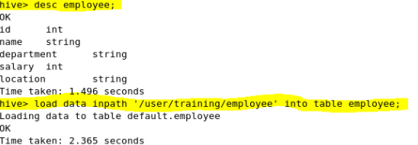

|  |
| --- |
|  |
|  | create table employee (id int, name varchar(45), department varchar(45), salary int, location varchar(45)); |
|  |  |
|  | INSERTION OF 10 RECORDS INTO THE TABLE |
|  | insert into employee (id,name,department,salary,location) values (1,'AAA','BBB',1000,'CCC'),(2,'BBB','BBB',1000,'CCC'),(3,'CCC','BBB',1000,'CCC'),(4,'DDD','BBB',1000,'CCC'),(5,'EEE','BBB',1000,'CCC'),(6,'FFF','BBB',1000,'CCC'),(7,'GGG','BBB',1000,'CCC'),(8,'HHH','BBB',1000,'CCC'),(9,'III','BBB',1000,'CCC'),(10,'JJJ','BBB',1000,'CCC'); |
|  |  |
|  | SQOOP IMPORT INTO HDFS |
|  | sqoop import --connect jdbc:mysql://localhost/employee --username root --table employee --m 1 --target-dir employee |
|  |  |
|  | SQOOP IMPORT INTO HIVE TABLE |
|  |  |
|  | sqoop create-hive-table --hive-table employee --connect jdbc:mysql://localhost/employee --username root --table employee |
|  | load data inpath '/user/training/employee' into table employee; |